***CYCLE MODULE***

Tables:

Cycle table is needed to encapsulate activities that repeated until the main purpose is served.

***Example***,:

Harvet is an ongoing activity that is broken down into cycles. During each cycle pods form entire plantation get picked. The prosess starts at plot 1 and ends when all plots are visited.

Harvest cycle may take two weeks or more depending on the season.

Each day of the cycle same activity being performed. Human, material and machine resourses are being recorded.

|  |  |  |  |
| --- | --- | --- | --- |
| CYCLE | |  |  |
| PK | Cycle_ID |  |  |
| PK | IDcrop | FK |  |
|  | IDactivityName | FK |  |
|  | HR required |  | Boolean |
|  | Machine required |  | Boolean |
|  | Service required |  | Boolean |
|  | Materials required |  | Boolean |
|  | Cycle number |  | smallint |
|  | Initial Date |  | Date |
|  | Final Date |  | Date |
|  | Cost of HR Budget |  | real |
|  | Cost of HR Actual |  | real |
|  | Cost of Machines Eq. Budget |  | real |
|  | Cost of Machines Eq. Actual |  | real |
|  | Cost of Services Budget |  | real |
|  | Cost of Service Actual |  | real |
|  | Cost of Materials Budget |  | real |
|  | Cost of Materials Actual |  | real |

***Register new CYCLE:***

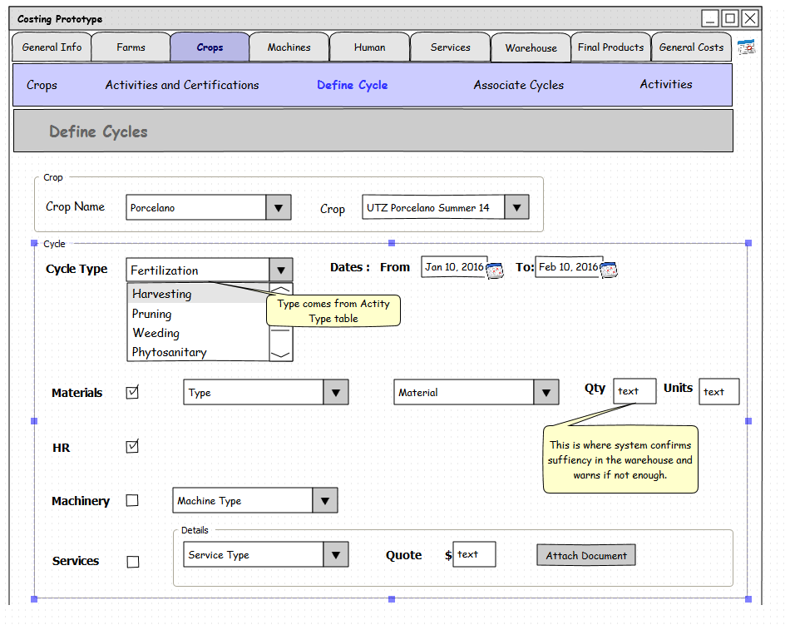

***Manage CYCLES:***

